

ADMINISTRATIVE
SUPPORT TEAM
(255)

NATIONAL 2020

Production:

Job 1: Volunteer Certificate (100 points)
Job 2: Flyer Promotion (100 points)
Job 3: 2 page Report (100 points)
Job 4: Spreadsheet (100 points)
Job 5: Thank you Letter (100 points)
TOTAL POINTS (500 points)

Graders: Please double check and verify all scores and answer keys!

Property of Business Professionals of America.
May be reproduced only for use in the Business Professionals of America
Workplace Skills Assessment Program competition.

Grading Rubric

Job 1 – Volunteer Certificate | Possible Points | Points Awarded
Includes the following: (10 points each)  - Name of award: PBA Volunteer Award  - Presented to  - Signature Line and name and title  - Dateline  - “This certificate is good for dinner for two at any Columbus area restaurant” at bottom  - Appropriate border | 60
Add other items/graphics to make certificate presentable | 30
Contestant ID and Job # in footer | 10
Job 1 Total | 100
Job 2 – Flyer | Possible Points | Points Awarded
Flyer (Production Standards)  0 errors - 70 points, 1 error - 50 points, 2 errors - 40 points,  3 errors – 30 points, 4+ errors – 0 points | 70
Formatting & Design | 10
Text inserted correctly | 10
Contestant ID and Job # in footer | 10
Job 2 Total | 100
Job 3 –2 page Report | Possible Points | Points Awarded
Report (Production Standards)  0 errors - 80 points, 1 error - 70 points, 2 errors - 50 points,  3 errors – 40 points, 4+ errors – 0 points | 80
Contestant ID and Job # in footer | 10
Report printed on 2 pages only | 10
Job 3 Total | 100
Job 4- Spreadsheet with Formulas
Data inputted correctly (Production Standards)  0 errors - 60 points, 1 error - 50 points, 2 errors - 40 points,  3 errors – 30 points, 4+ errors – 0 points | 60
Landscape Orientation (fits to one page) | 10
All table data is displayed | 10
Style is inserted | 10
Contestant ID and Job # Centered in footer | 10
Job 4 Total | 100
Job 5- Thank You Letter
Letter correctly (Production Standards)  0 errors - 100 points, 1 error - 90 points, 2 errors - 70 points,  3 errors – 50 points, 4+ errors – 0 points | 100
Job 5 Total | 100
TOTAL | 500

JOB 1: Volunteer Certificate

Note to grader: There are several ways this certificate could be created. However, the directions contestants to create it in Word. Please use rubric for grading purposes. This is an EXAMPLE.
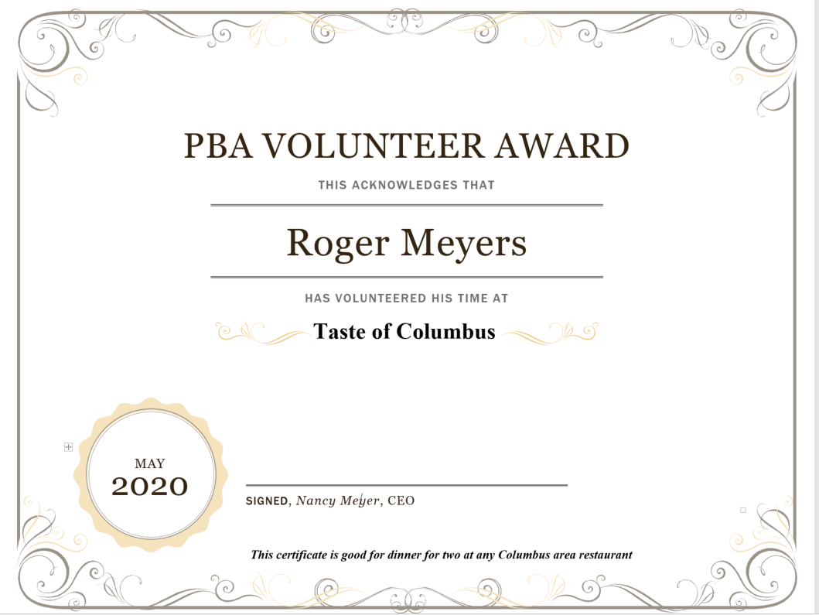
Nancy Wells, CEO

JOB 2: Flyer

Note to grader: There are several ways this flyer could be created. However, the directions asks them to use their creativity in designing the flyer. Please use rubric for grading purposes. This is what needs to be on the Flyer.

• PBA Employee Wellness Room
• Include an appropriate border
• “Free” to Employees
• Massage Chairs
• Mindfulness classes
• Health Cooking
Job 3 2 page Report
Meyer 1

Roger Meyers
Department Heads
Department Managers
Current Date (military style)
Mindfulness at Work
Mindfulness may seem like a great idea, but how do you become more mindful in the context of a busy workday? You may have emails, phone calls, meetings, and presentations to deal with. In the middle of all that, how can you apply the principles of mindfulness so that you feel more alive and present, as well as being productive? Here are a few popular and other more radical ways to be mindful at work.
Be Consciously Present
Mindfulness is, above all, about being aware and awake rather than operating unconsciously. When you are consciously present at work, you’re aware of two aspects of your moment-to-moment experience—what’s going on around you and what’s going on within you. To be mindful at work means to be consciously present in what you are doing, while you’re doing it, as well as managing your mental and emotional state. If you are writing a report, mindfulness requires you to give that your full attention. Here are some ideas to help you stop being mindless, unconscious at work, more mindful, and consciously present:
Make a clear decision at the start of your workday to be present as best you can. Pause for a few moments before you start your workday to set this intention in your mind.
Use Short Mindful Exercises at Work
Mindful exercises train your brain to be more mindful. The more mindful exercises you do, the easier your brain finds it to drop into a mindful state, thus optimizing your brain function. In the busy workplace, finding time for a 30-minute mindful exercise can be difficult. So does that mean you can’t be mindful at all at work? Nope. Mindful exercises can be as short as you wish. Even one minute of consciously connecting with one of your senses can be classified as a mindful exercise. You do not need to close your eyes. You do not even need to be sitting down. Be creative about finding slots in the day to practice mindfulness exercises. At times of excessive pressure at work, practicing a short mindfulness exercise can be a helpful.
Use Mindful Reminders
Meyer 2
The word “mindful” means to remember. Most people who have read about or undertaken training in mindfulness appreciate the benefits of mindful living. Unfortunately, they keep forgetting to be mindful! The reason you forget to be mindful is that your brain’s normal (default) mode is to be habitually lost in your own thoughts—running a sort of internal narrative. When you are going about your usual daily activities, your brain switches you into this low energy state, which is unmindful, almost dreamy. Doing some things automatically, without thinking, is fine but research undertaken at Harvard University showed that 47 per cent of a person’s day can be spent lost in thoughts. By using some form of reminder, you can be mindful again. The reminder shakes you out of autopilot mode. Try these reminders:
Setting an alarm on the phone – even a vibrating alarm that doesn’t disturb others can work well.
Therefore, every time your phone rings, you take a mindful breath. Every time you hear the ping of a text message, you pause to be mindful of your surroundings rather than immediately reacting by checking the message. All these things are opportunities to come back into the present moment, to see yourself and your surroundings afresh. You take a small step back and reflect rather than automatically react to what’s coming at you in the form of demands, tasks, and challenges.

JOB 4: Spreadsheet
Note to grader: These printouts reflect the style. Please follow rubric for grading purposes. The second printout shows descending, the third printout shows formulas

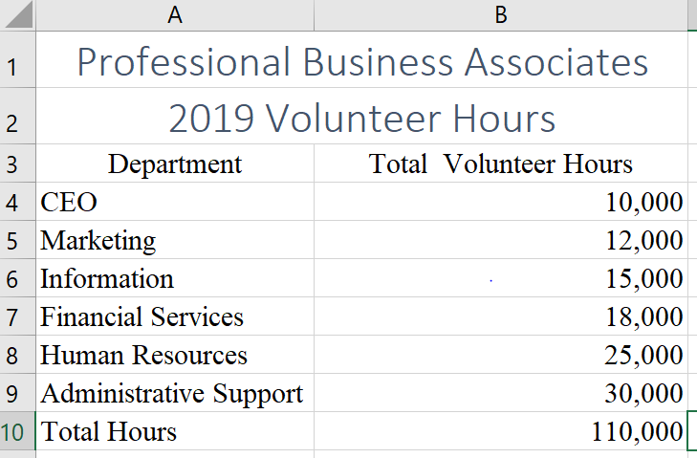
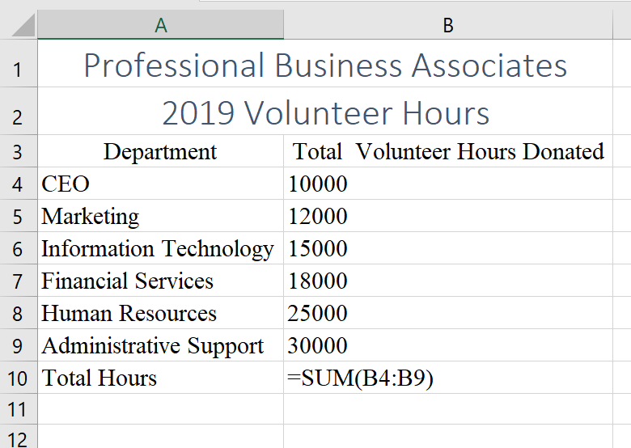

JOB 5: Thank You Letter
